RL for Dynamic No-trade Zone (Baseline method):

Single-day lookahead:
- State: [W_t, w_t, r_{t-10:t}, regime, …]
- Action: RL decides optimal [A, B] bounds for each train/val/test rolling window, where A is the lower bound of no-trade zone, and B is the higher bound of no-trade zone
  - can start with symmetric [A, 1-A] pairs
- Reward: per-step reward (net return), long-term reward (log-Utility net wealth)
  - See below for multi-step lookahead reward
- Decide the best [A, B] bounds on the validation period, and apply the bounds on the testing window; Update models biannually / quarterly to respond to market trends
- Need a large volume of simulation data that closely resembles real data
  - Synthetic data: HMM, T-mixture, Gaussian-mixture, etc.

Multi‑step lookahead:
Combine multi-day cumulative return into reward function: redefine the reward as the next 5-day cumulative return (plus penalties like costs, drawdown, etc.), so the agent learns policies that optimize actions today based on their impact over a 5-day horizon.
- Offline Training (multi-step lookahead): In financial backtesting, during we you have access to the full historical sequence → we can use the realized returns from t+1 to t+5 to construct the 5-step reward
- Online Testing (provide one-step reward): we do not know the returns of the next five days, the environment returns current step reward → however, the agent has already learned the optimal trade/no-trade policy for the current market state s_t from training data, so it only needs to make one-step decisions at current state s_t.
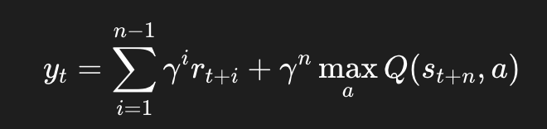
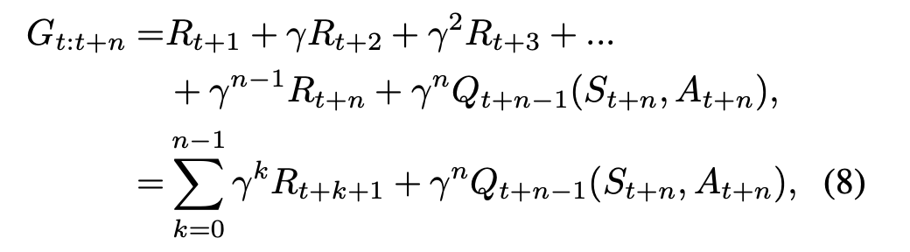
(multi-step Temporal Difference update of value function)
Deep reinforcement learning for portfolio selection: https://www.sciencedirect.com/science/article/pii/S1044028324000887
Reinforcement Learning for Optimal Execution when Liquidity is Time-Varying https://arxiv.org/html/2402.12049v2
An End-to-End Optimal Trade Execution Framework based on Proximal Policy Optimization https://dl.acm.org/doi/pdf/10.5555/3491440.3492067
https://www.sciencedirect.com/science/article/abs/pii/S0952197625001812 (multi-step DDPG)
https://arxiv.org/pdf/1703.01327#:~:text=Multi,11%20Jun%202018 (multi-step SARSA)
https://www.sciencedirect.com/science/article/pii/S0306261919314424
https://pubsonline.informs.org/doi/10.1287/moor.13.2.277

Separate RL model (Allocation RL + Return Prediction RL + decision rule):

One-step lookahead:
One model for portfolio allocation without considering t-cost, and a separate model to predict next-day return. Then, compare the results of rebalancing vs not rebalancing
- Refer to Silu’s paper for similar idea
- Action space of allocation RL: decide optimal allocation weights without considering t-cost
- Action space of return prediction RL: predict the t+1 return
- A final binary decision rule - if (forecasted return after rebalance - t-cost) > forecasted return if not rebalance, then rebalance

Multi-step lookahead:
Predict the returns from t+1 to t+5 using LSTMs / XGBoost (or other forecasting methods), and decide whether to rebalance today, given the prediction
- Issue: compounding prediction error
- Issue: We assume no rebalance happens on t+1 to t+4; we only focus on if we need to rebalance at time t given t+5’s prediction result

Hierarchical RL (allocation RL + trade/no trade RL):

One-step lookhead:
High-level RL agent deals with portfolio optimization, lower-level RL agent deals with transaction cost and reflects trade / no trade decision to higher level
High-level RL reward function (deal with allocation): maximize overall long-term utility function to determine rebalance weights (not considering t-cost)
Action: optimal rebalance weights without t-cost
state: regime, return features, macro features, regime
low-level RL reward function (deal with t-cost): R_t(x_t) - c_t(x_t, w_t) - lambda * risk penalty_t
action: determine trade or not trade based on transaction cost (t->t+5)
state: past returns, transaction cost (linear), return & macro features, regime

Multi-step version of Hierarchical RL:
Lower-level RL decides if rebalancing weights from higher-level will bring more benefits (5-day return - t-cost) than not rebalancing

https://cdn.aaai.org/ojs/16142/16142-13-19636-1-2-20210518.pdf [Hierarchical RL to address price slippage and trading execution]
https://www.techrxiv.org/users/692350/articles/1184096-multi-scale-reinforcement-learning-of-dynamic-energy-controller-for-connected-electrified-vehicles [Hierarchical RL]
https://www.cs.cmu.edu/~epxing/Class/10708-19/assets/project/final-reports/project5.pdf#:~:text=stead%2C%20we%20build%20a%20hierarchical,org%2Fwiki%2FBlackScholes%20model [Hierarchical RL]

